
FINAL PROJECT REPORT
OBJECT ORIENTED PROGRAMMING - FALL 2025

Name, Surname | Melisa Gürlük
Student ID | 230303007
Name of the Project | Banking System

PROJECT DESCRIPTION

The Banking System project is an object-oriented system designed to automate and manage core financial operations. It solves the common problem of manual transaction tracking by providing a structured logic for managing different account types, such as Savings and Checking accounts. The system is intended for bank administrators and authorized users, allowing them to perform precise deposits, withdrawals, and inter-account transfers while maintaining a detailed, time-stamped record of all activities.

The system works by following specific rules for each type of account to ensure money is managed correctly. For example, it automatically checks if a user has enough balance before a withdrawal or calculates interest for savings accounts to help them grow. Through the console, users can easily see their past activities and the bank can track the total amount of money across all accounts, making the whole banking process organized and error-free.

UML DIAGRAMS

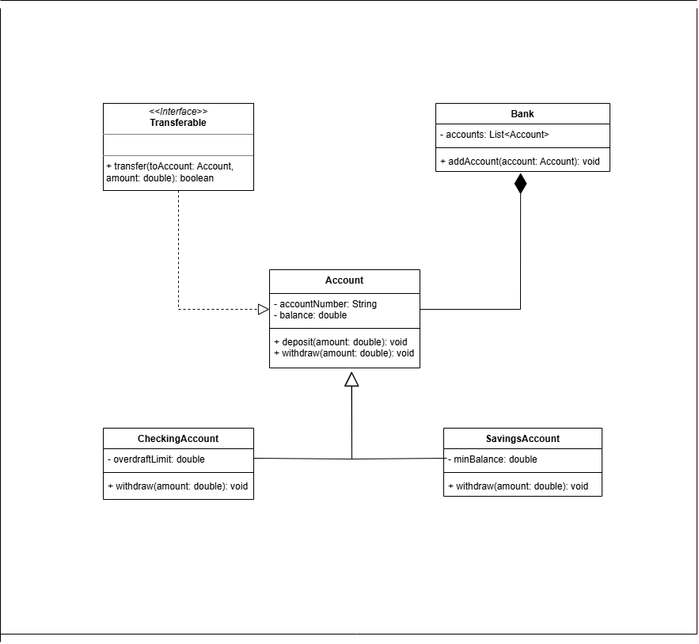
This class diagram shows the inheritance relationship between Account, SavingsAccount, and CheckingAccount, as well as the implementation of the Transferable interface.

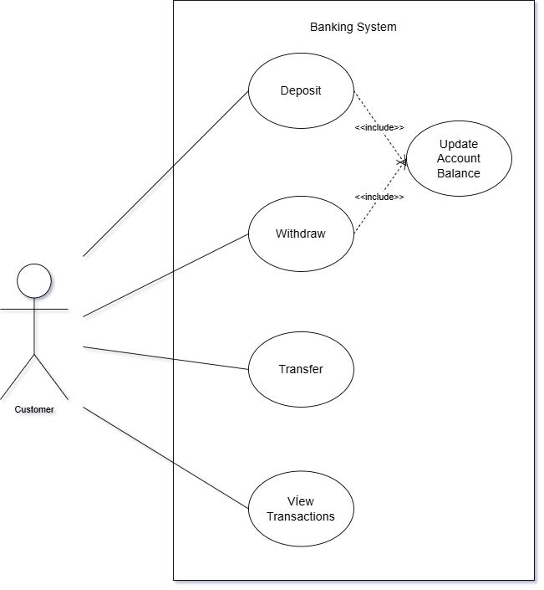

This use-case diagram illustrates the interactions between the User and the Banking System, such as performing transactions and managing accounts.

SYSTEM DESIGN

Number of classes | 7
Number of interfaces | 1
Number of abstract classes (if any) | 1

Short explanation of your classes:

Account | The base abstract class that defines the common properties and withdrawal rules for all bank accounts.
SavingsAccount | A specialized account that handles interest calculations and maintains a required minimum balance.
CheckingAccount | An account designed for daily transactions that allows spending beyond the balance up to a set overdraft limit.
Bank | The central system used to manage all accounts, calculate total balances, and process loan approvals.
Transaction | A helper class that automatically logs every financial move with a type, amount, and exact date/time.
Main | The entry point where the entire banking system is initialized and different scenarios are simulated for demonstration.
AccountTest | The testing suite that uses JUnit to automatically verify if all banking logic and account rules work correctly.

Explain how did you accomplish the following:

Encapsulation | I made fields like balance private so they cannot be changed directly from outside. I used getter methods to allow controlled access to data, and I ensured that any balance modifications only happen through verified methods like deposit() and withdraw() to prevent errors.
Inheritance | I used the extends keyword to create a hierarchical structure where Account is the base class. Specialized classes like SavingsAccount and CheckingAccount inherited common properties (like balance) while adding their own specific features such as interest rates and overdraft limits.
Polymorphism | I used Method Overriding for the withdraw() function in subclasses. This allowed the same method to behavce differently for each account; for example, a CheckingAccount can go below zero (overdraft) while a SavingsAccount checks for a minimum balance.
Interfaces | I implemented the Transferable interface to set a standard rule for money transfers. This forces every account type to have its own transfer() method, ensuring that all accounts can safely exchange funds regardless of their type.

UNIT TESTING

How many classes you’ve tested? | 3

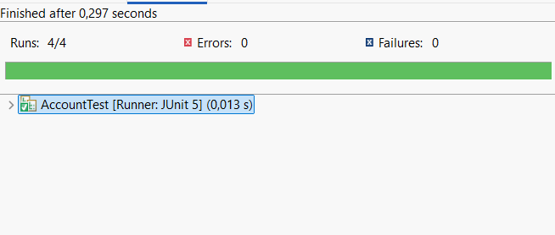

GIT & GITHUB

Github Repository Link: | https://github.com/melisagrlk/OOP-Banking-System.git
Github Projects Link: | https://github.com/users/melisagrlk/projects/1

